**Department of Computer Science and Engineering**

**Sub: iOS application development using swift**

**Assignment No 1**

1. Declare a constant named maxSpeed with a value of 120 and a variable currentSpeed with an initial value of 60. Then, modify the value of currentSpeed to 100. What will happen if you try to modify maxSpeed after it's initialized?

Ans:

let maxSpeed = 120

var currentSpeed=60

print("Before modify: currentSpeed = \(currentSpeed)")

currentSpeed=80

print("After modify: currentSpeed = \(currentSpeed)")

Op:

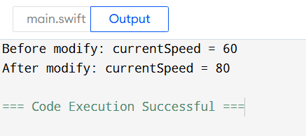

When we try to modify an maxSpeed value it provide an error

maxSpeed=100

Op:

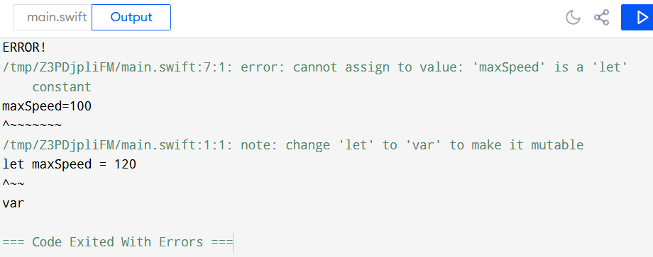

It provide an error that we cannot resign an value to the maxSpeed , because we declare a variable as constant as mention is question so once we assign an value to constant ot cannot be changed throughout the program

1. Write code where a constant stores the value of a person's age and a variable stores their current score in a game. Demonstrate why one needs to be a constant and the other a variable.

Ans:

let age=21

var score=100

print("A person \(age) years old scores \(score) in Game")

op:

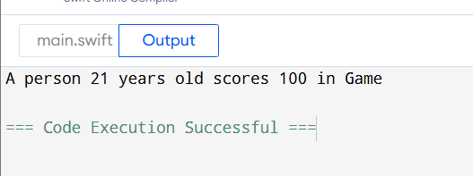

Here in this Question we declare an person age as constant because the age can be constant while playing a game but the score is changing continuously as he/she plays continuously so that we declare score an var so that it can be change/ modify during game.

1. Declare a constant score of type Int and attempt to assign a String value to it. What happens? Fix the error.

Ans:

let score:Int= "String"

print(score)

Op:

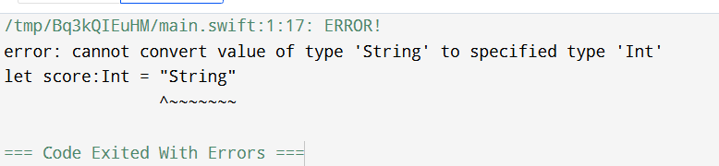

Program give an error that is “ cannot convert of type ‘String’ to specified type ‘Int’ “, because we declare a score an constant integer and assign an string value to it which provides an error

To fix this we need to assign an inter value to constant score:

let score:Int = 18

print(score)

op:

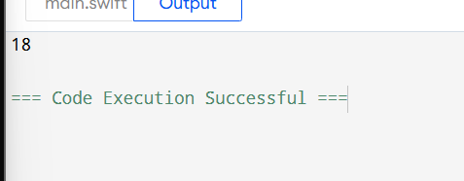

1. Declare a variable greeting and initialize it with the string "Hello, world!". What type will Swift infer for this variable? Print the type using type(of:).

Ans:

var greeting = "Hello, world"

print(type(of:greeting))

Op:

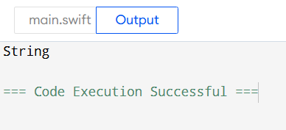

As we initialize greeting with String it gives output “String ” as type of variable.

1. Declare a variable productPrice with type annotation Double and initialize it with the value 49.99.

Ans:

var productPrice:Double = 49.99

print(productPrice)

OP:

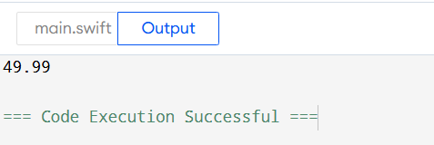

1. Write a program that uses a switch statement to print the day of the week. Given a number between 1 and 7, print:

1: "Monday"

2: "Tuesday"

3: "Wednesday"

4: "Thursday"

5: "Friday"

6: "Saturday"

7: "Sunday"

Ans:

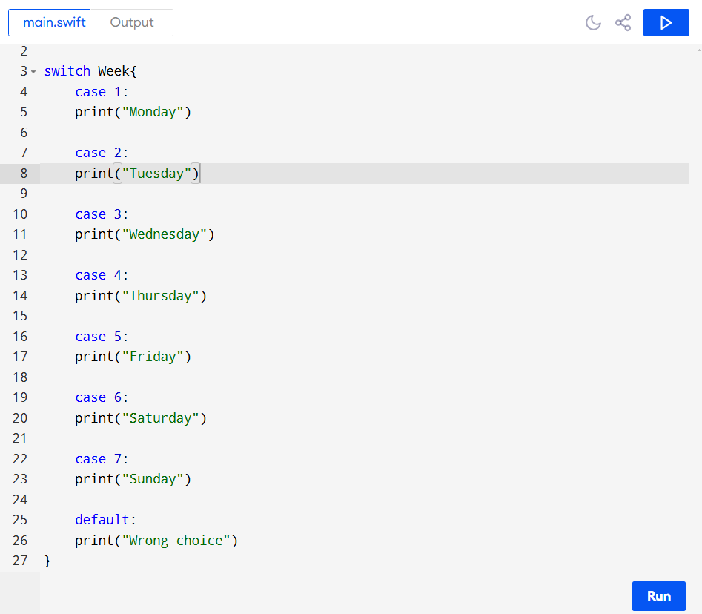

Op:

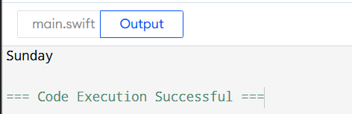

1. Write a program that takes an age as input and prints the category the person falls into using a switch statement:

0–12: "Child"

13–19: "Teenager"

20–64: "Adult"

65 and above: "Senior"

Ans:

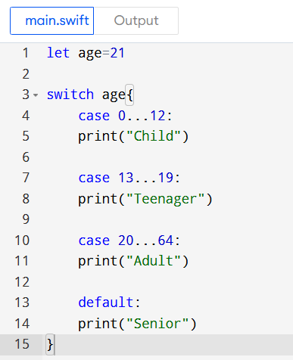

Op:

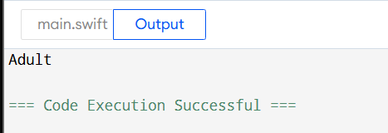

1. Write a program that checks the current temperature. If the temperature is below 0°C, print "Freezing". If it's between 0°C and 20°C, print "Cold". If it's above 20°C, print "Warm".

Ans:

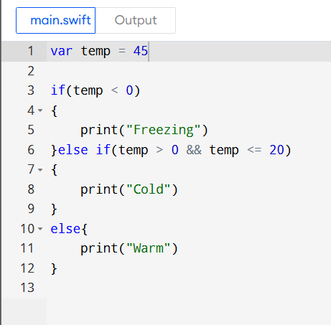

Op:

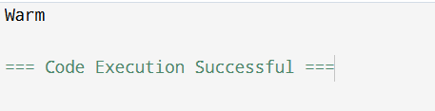

1. Write a program that checks if a person is eligible for a loan. The person is eligible if:

* They are at least 21 years old.
* They have a credit score of 700 or higher.
* If both conditions are true, print "Eligible for loan", otherwise print "Not eligible for loan".

Ans:

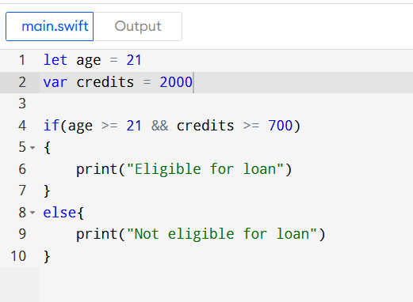

Op:

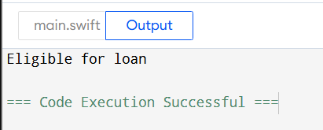

1. Write a program that uses a switch statement to determine the grade based on the score:

* 90–100: "A"
* 80–89: "B"
* 70–79: "C"
* 60–69: "D"
* 0–59: "F"

Ensure the switch statement covers all possible cases.

Ans:

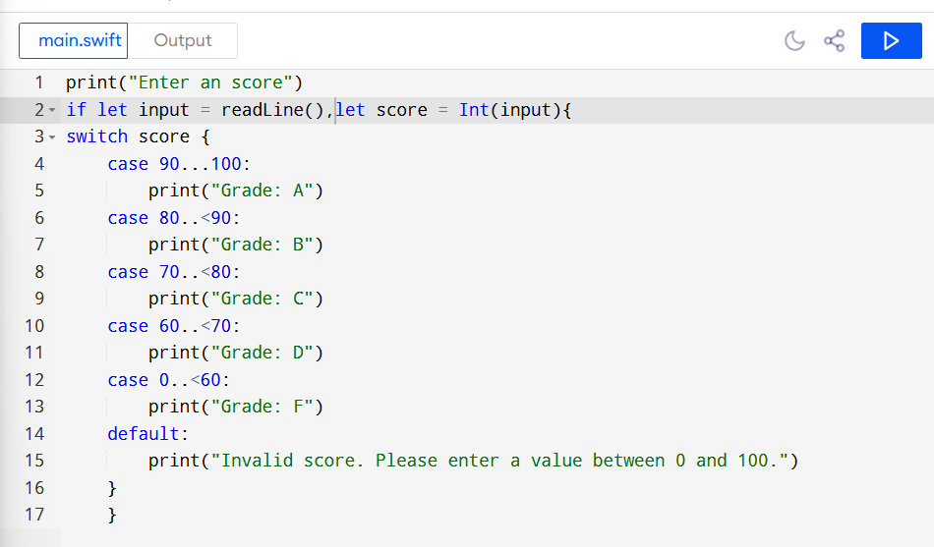

Op:

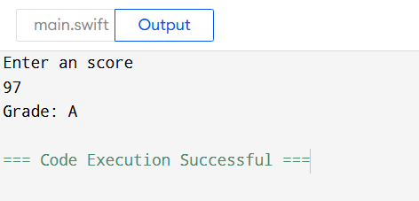

1. Write a program that checks if the entered password is correct. Declare a Boolean variable isPasswordCorrect:

* If the value of isPasswordCorrect is true, print "Access granted".
* If the value is false, print "Access denied".

Ans:

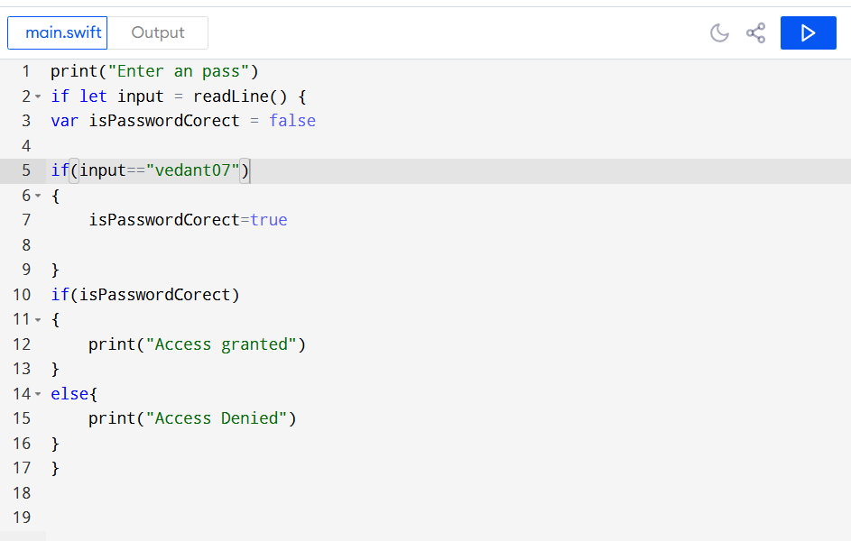

Op:

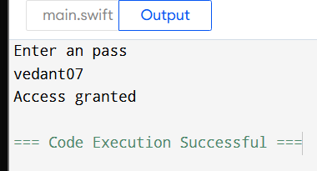

1. Write a program that suggests an activity based on whether it's a weekend and if it's raining:

* Use isWeekend and isRaining as boolean variables.
* If it's a weekend and it's not raining, print "Go hiking".
* If it's a weekend and it's raining, print "Watch a movie".
* If it's a weekday, print "Go to work".

Ans:

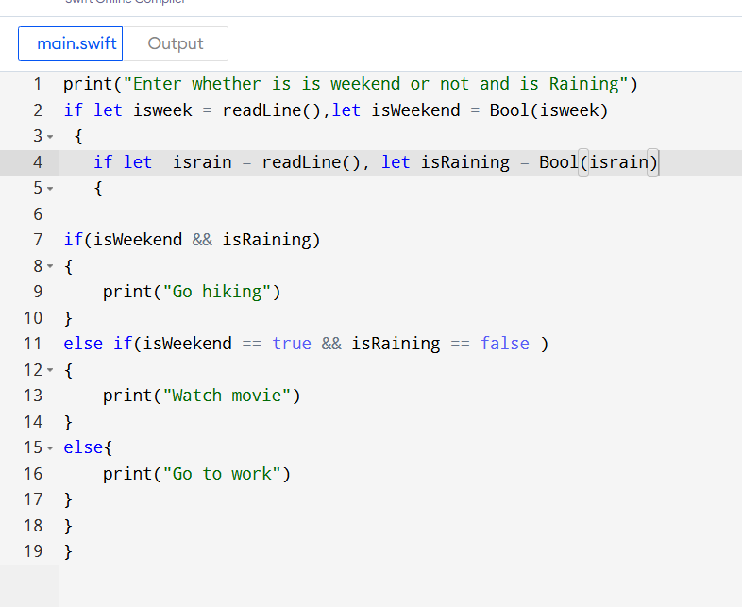

Op:

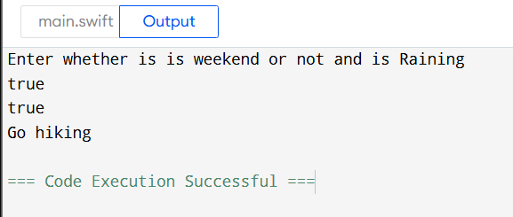

1. Write a program that uses the ternary operator to evaluate a student's grade:

* If the grade is 60 or higher, print "Passed". Otherwise, print "Failed".
* Use the ternary operator to check the grade and assign the result to a variable.

Ans:

if let input = readLine(), let score = Int(input) {

score >= 60 ? print("Passed") : print("Failed")

}

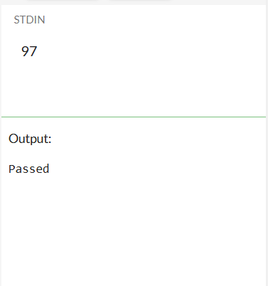

1. Declare a name constant and assign your name as a string literal with proper capitalization. Then declare an age constant and give it your current age as an Int.

Write an if-else statement that checks to see if name is in capitals, If yes Then print the following phrase using string interpolation: My name is and after my next birthday I will be years old. Insert name where indicated, and insert a mathematical expression that evaluates to your current age plus one where indicated.

Ans:

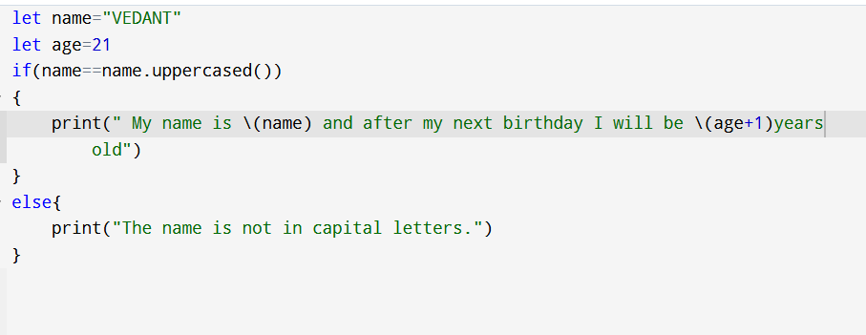

Op:

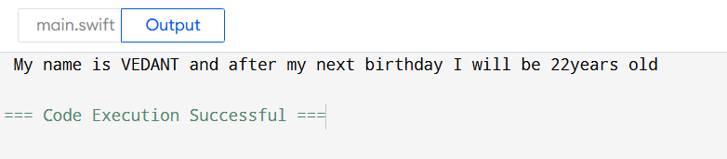

1. Imagine you are looking through a list of names to find any that end in Jr; Write an if statement below that will check if “junior” has the suffix;Jr If it does, print We found a second generation name;

let junior =Cal Ripken Jr;

Ans:

